Building an ESB Proxy with WSO2 Micro Integrator & VS Code
Edirimanna Y.H.
E/20/089
GitHub repository link- https://github.com/YasiruHarinda/CO528-Labs/tree/main/CE-PDN-AC-LK-ESB
Create a New Integration Project
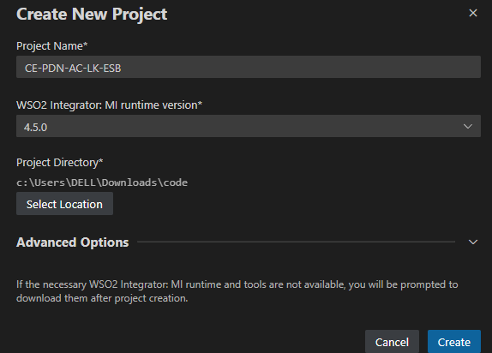
Create HTTP Endpoints for the Backend APIs
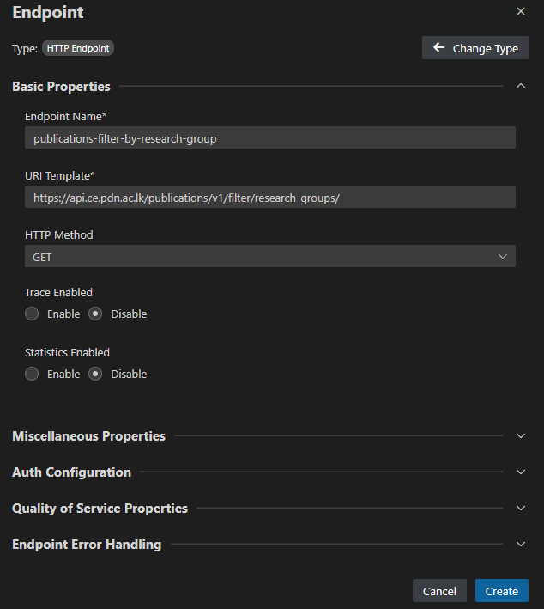
This will create an endpoint XML
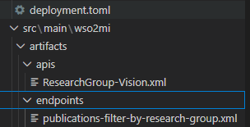

Add Resource


Wire the API to the Endpoints
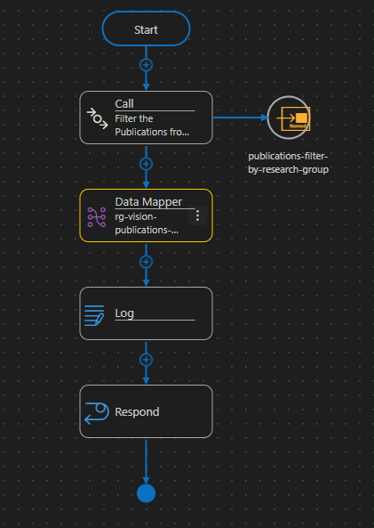
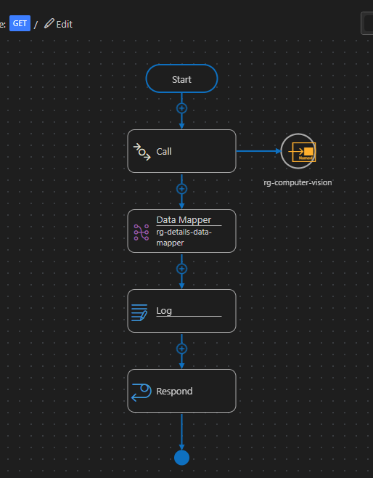
outputs
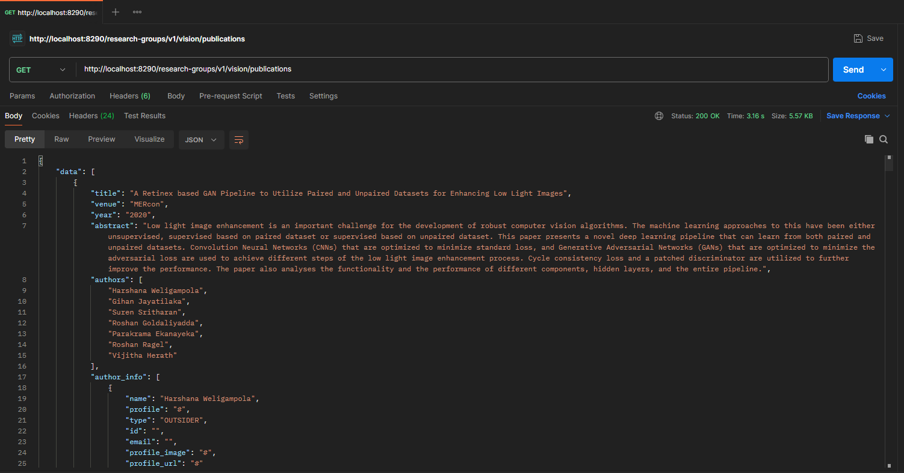
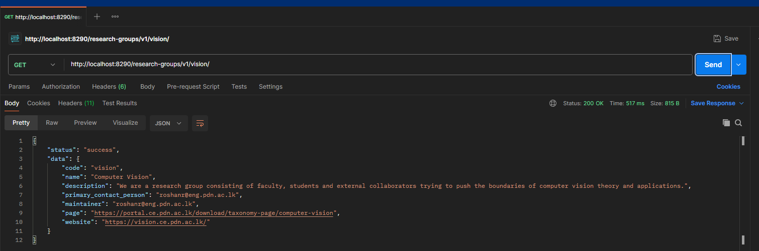
MI console logs
how the ESB based Research Group API simplifies department API management
- The ESB helps ensure consistency in the structure of the data fed into the client applications despite changes in the structure of the services within an organization.

- It mainly routes the request to the proper back-end services without having the clients need to route the request.

- By acting as an intermediary, the ESB can decrease the dependencies between clients and backend systems.

- The ESB enables centralized monitoring, which enhances visibility when dealing with APIs.

- Overall, ESB improves both stability and controllability in interactions involving department APIs.

